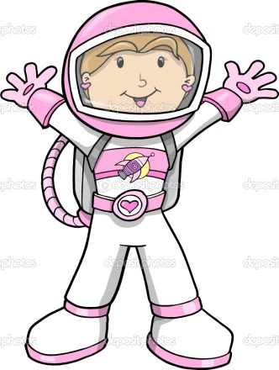
Anna the Astronaut will help you achieve Set A.
Recall addition doubles up to 5+5.

Recall addition and subtraction facts up to 5.
Recall pairs of numbers which total 10.

Count on or back in tens from zero and cross 100.
Count on or back in ones from zero and cross 100.
Count on or back in fives from zero and cross 100.
Recall addition and subtraction facts up to 10.
Count on or back in twos from zero and cross 100.
Recall pairs of numbers which total 20.

Now collect your medal and set off on your second quest…

