Examples of what children should be able to do, in relation to each (boxed) Programme of Study statement
recognise, find, name and write fractions ¹⁄₃,¹⁄₄ ,²⁄₄ and ³⁄₄ of a length, shape, set of objects or quantity
Using bar models to represent and unpick a fraction word problem
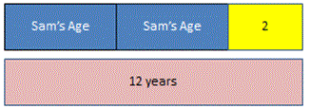
Harrison and Sam were talking and Harrison said that if he doubled Sam's age and added 2 he would get 12

write simple fractions for example,½ of 6 = 3 and recognise the equivalence of ²⁄₄ and ½
Would a chocolate lover rather have ½ or ³⁄₅ of this bar of chocolate? Explain your answer.

Non-Statutory Guidance
Pupils use fractions as ‘fractions of’ discrete and continuous quantities by solving problems using shapes, objects and quantities. They connect unit fractions to equal sharing and grouping, to numbers when they can be calculated, and to measures, finding fractions of lengths, quantities, sets of objects or shapes. They meet ¾ as the first example of a non-unit fraction.
Pupils should count in fractions up to 10, starting from any number and using the ½ and ²⁄₄ equivalence on the number line (for example, 1 ¼ , 1 ²⁄₄ (or 1½ ), 1¾ , 2). This reinforces the concept of fractions as numbers and that they can add up to more than one.

