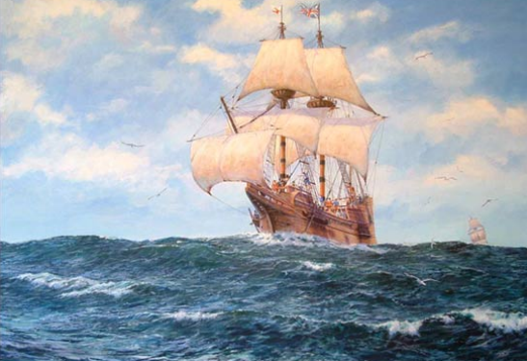
Learning letter
WB 20.9.20

What a great week we have had! We have loved learning about the Mayflower. We especially enjoyed making crepe paper dolls, like the Wampanoag’s corn husk dolls and Mayflower boats in all sorts of ways!

Thank you to parents who contributed to the news article from Plymouth Live about our first day!
Things we have been learning:
- to say our daily prayers and use our prayer space if we’d like
- to recognise and write our name and find our pictures
- to be a listening lion and choosing chimp
- to know that we are precious
- we started our RWI this week, we have learnt the sounds m, a, s, d, t
- to use our emergent marks to write secret messages!
- Teeth brushing

Homelearning
Homelearning is optional but anything you do at home is a great help for your child!
- Please read and enjoy pages 5-13 together. We are so glad you are enjoying the book and share the love of reading with your children.
- Continue to practise writing your name using the card from your home visit.
- We have learnt these sounds: m, a, s, d, t, please have a go at the sound sheets with your child. Remember the sayings that helps with letter formation is in your pack. We are not doing the red instructions yet (for joined writing).
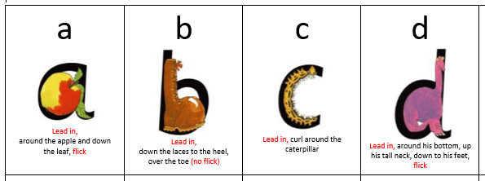
- If you haven’t already, enjoy having a look at Tapestry with your child!
- Numbots- we have stuck your child’s password for both Numbots and IXL into their home learning diary. Feel free to have a look around the Story mode on Numbots. We will be using these later on this year for some of our home learning.

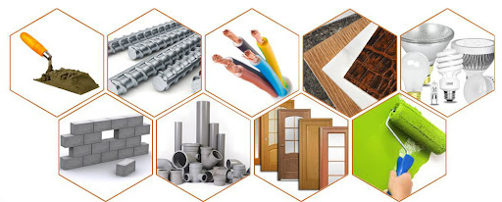
We are really excited about our next two weeks of immersive learning. We will be doing Science looking at materials. Please could you raid your recycling bins! We would love any of the below (clean and not sharp) please:
- metal (tin foil, foil trays, tins ect.)
- plastic (bottles, tubs, bags, bubble wrap)
- rubber (if you have any!)
- cardboard & paper (cereal boxes, corrugated, leaflets)
Have a lovely weekend!

