Examples of what children should be able to do, in relation to each (boxed) Programme of Study statement
draw 2-D shapes using given dimensions and angles
Children should be able to construct a triangle given two sides and the included angle
Here is a sketch of a triangle. (It is not drawn to scale).
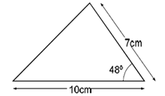
Draw the full size triangle accurately, below. Use an angle measurer (protractor) and a ruler. One line has been drawn for you.

recognise, describe and build simple 3-D shapes, including making nets
Children should be able to identify, visualise and describe properties of rectangles, triangles, regular polygons and 3-D solids; use knowledge of properties to draw 2-D shapes and identify and draw nets of 3-D shapes
They should be able to respond accurately to questions such as;
‘I am thinking of a 3D shape. It has a square base. It has four other faces which are triangles. What is the name of the 3D shape?’
‘Which of these nets are of square based pyramids? How do you know?
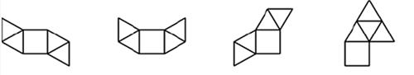
‘Is this a net for an open cube?’ How do you know?
compare and classify geometric shapes based on their properties and sizes and find unknown angles in any triangles, quadrilaterals, and regular polygons
Children should be able to make and draw shapes with increasing accuracy and knowledge of their properties.
They should be able to carry out activities such as;
‘Give me instructions to get me to draw a rhombus using my ruler and a protractor’
‘On the grid below, use a ruler to draw a pentagon that has three right angles’

illustrate and name parts of circles, including radius, diameter and circumference and know that the diameter is twice the radius
They should know that:
- The circumference is the distance round the circle
- The radius is the distance from the centre to the circumference
- The diameter is 2 x radius

recognise angles where they meet at a point, are on a straight line, or are vertically opposite, and find missing angles
Children should be able to estimate angles, use a protractor to measure and draw them, on their own and in shapes. They should know that the angle sum of a triangle is 180˚, and the sum of angles around a point is 360˚.
They should be able to use this knowledge to respond accurately to questions such as;
‘There are nine equal angles around a point. What is the size of each angle?’
‘There are a number of equal angles around a point. The size of each angle is 24°. How many equal angles are there?’
Children should be able to calculate the size of angle ‘y’ in this diagram without using a protractor.
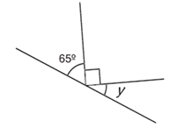
(Not to scale)

Non-Statutory Guidance
Pupils draw shapes and nets accurately, using measuring tools and conventional markings and labels for lines and angles.
Pupils describe the properties of shapes and explain how unknown angles and lengths can be derived from known measurements.
These relationships might be expressed algebraically for example:
d = 2 × r ; a = 180 – (b + c).

