Examples of what children should be able to do, in relation to each (boxed) Programme of Study statement
count up and down in tenths; recognise that tenths arise from dividing an object into 10 equal parts and in dividing one-digit numbers or quantities by 10
Children should be able to:
- Use decimal notation for tenths
- Divide single digits or whole numbers by 10
- Explain how finding 1/10 is the same as dividing by 10
Here is part of a number line. Write in the numbers missing from the two empty boxes.
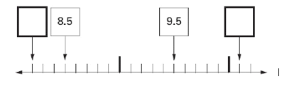

recognise, find and write fractions of a discrete set of objects: unit fractions and non-unit fractions with small denominators
Children should be able to:
- Recognise and write unit and non-unit fractions of shapes.
Unit Fractions. Unit means one. Here are some examples of unit fractions.
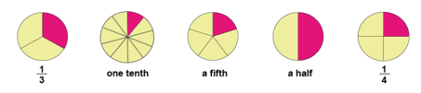
Can you spot the pattern? A unit fraction is one part of a whole that is divided into equal parts.
Non-unit fractions. Unit means one, so non-unit is any number apart from one. Here are some examples of non-unit fractions.
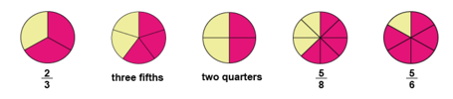
Many (or, rather, more than one of the) parts, of an equally divided whole, is a non-unit fraction.
Taken from: BBC skillswise different types of fraction
- Understand that the number on the bottom of a fraction tells me how many pieces the whole is divided into
What fraction of this shape is shaded? How do you know? Is there another way that you can describe the fraction?
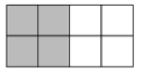
- Find fractions of amounts
Here are 21 apples. Put a ring around one third of them.
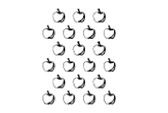

recognise and use fractions as numbers: unit fractions and non-unit fractions with small denominators
Children should be able to:
- Position fractions on a number line; eg. mark fractions such as ½, 3 ½ and 2 3/10 on a number line marked from zero to 5.
A fraction of each shape is shaded. Match each fraction to the correct place on the number line. One has been done for you.
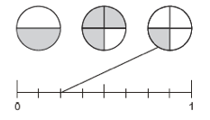

recognise and show, using diagrams, equivalent fractions with small denominators
Children should be able to:
- Identify pairs of fractions that total 1.
- Circle two fractions that have the same value.
add and subtract fractions with the same denominator within one whole (e.g. 5/7 + 1/7 = 6/7)
This could also be done by using drawings and in the array form:
For addition:
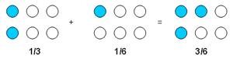
and for subtraction:
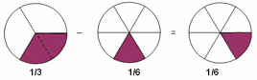

compare and order unit fractions, and fractions with the same denominators
Children should be able to:
- Would you rather have 1/3 of 30 sweets or 1/5 of 40 sweets? Why?

solve problems that involve all of the above
Children should be able to answer questions like:
- 15 grapes are shared equally onto five plates. What fraction of the grapes is on each plate?
- Meg has 20 pet stickers to go on this page:
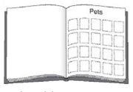
1/4 of them are dog stickers
1/2 of them are cat stickers
The rest are rabbit stickers
How many rabbit stickers does she have?

Non-Statutory Guidance
Pupils connect tenths to place value, decimal measures and to division by 10.
They begin to understand unit and non-unit fractions as numbers on the number line, and deduce relations between them, such as size and equivalence. They should go beyond the [0, 1] interval, including relating this to measure.
Pupils understand the relation between unit fractions as operators (fractions of), and division by integers.
They continue to recognise fractions in the context of parts of a whole, numbers, measurements, a shape, and unit fractions as a division of a quantity.
Pupils practise adding and subtracting fractions with the same denominator through a variety of increasingly complex problems to improve fluency.

