Examples of what children should be able to do, in relation to each (boxed) Programme of Study statement
read, write, order and compare numbers up to 10 000 000 and determine the value of each digit
Children should be able to determine the steps used in different scales, and so complete activities such as;
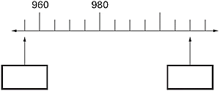

round any whole number to a required degree of accuracy
Children should be able to circle the best estimate of the answer to questions such as;
72.34 ÷ 8.91
When given
6 7 8 9 10 11 as possible answers
Children should estimate the position of numbers on a number line. They should suggest which number lies about two-fifths of the way along a line from 0 to 1000, or a line from 0 to 1. They should be able to justify their decisions.

use negative numbers in context, and calculate intervals across zero
Children should be able to work with negative numbers in a similar way, determining values on a scale and estimating.
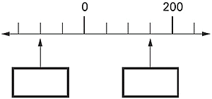

solve number and practical problems that involve all of the above
Children should be able to use rounding and inverse operations to estimate and check calculations such as;
The temperature inside an aeroplane is 20°C The temperatures outside the aeroplane is -30°C. What is the difference between these temperatures?

Non-Statutory Guidance
Pupils use the whole number system, including saying, reading and writing numbers accurately

