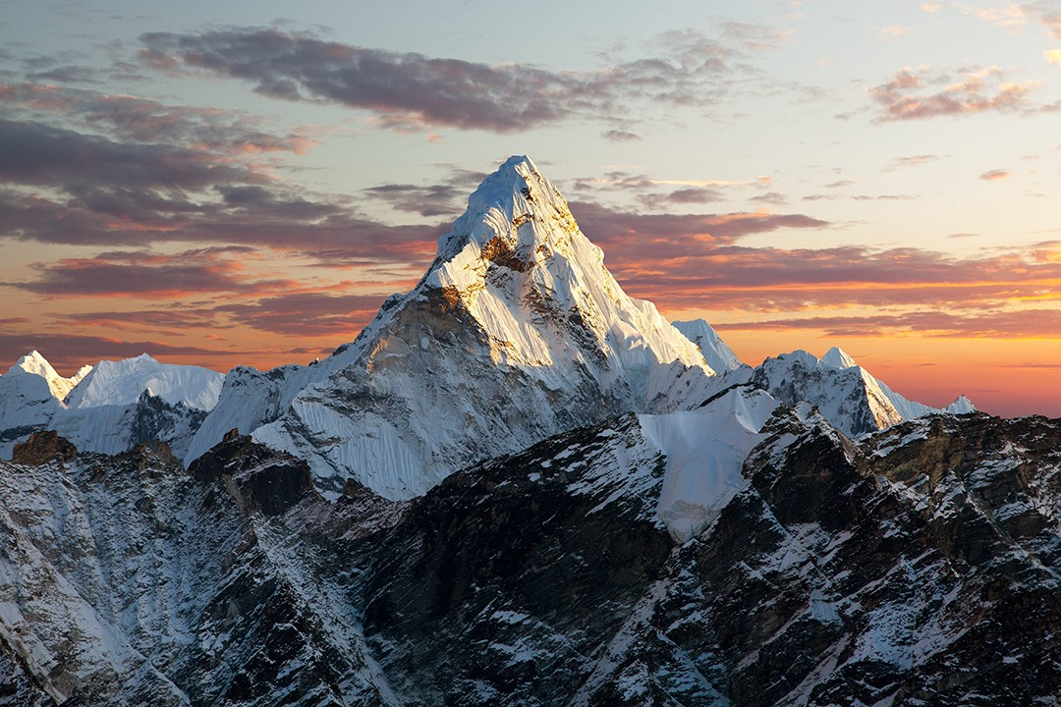

**Art**

Zentangle mountain art

**DT**

Healthy sandwiches and wraps

**French**

Days of the week and months of the year

Birthdays/Christmas/

other celebrations

Shapes and colours

**Music**

Ukuleles with an outside tutor

**English**

Explanation texts

Stories with dilemmas

Letters

Setting descriptions

Stories in imaginary

worlds

**Maths**

Multiplication and

Division

Area

Fractions and

decimals

**Mountains and Europe**

**RE**

Local Church

Islam

Eucharist

Lent/Easter

**Science**

Forces and Magnets

Sound

**History**

Not covered this term

**Geography**

Mountains

Europe

**Computing**

Desktop Publishing

Data logging

**PE**

Dance – cold places

Gymnastics – rolls

ARGYLE

**PSHE**

Staying safe in a digital World

My mental and physical wellbeing