Examples of what children should be able to do, in relation to each (boxed) Programme of Study statement
recognise, find and name a half as one of two equal parts of an object, shape or quantity
Here is a set of 12 pencils
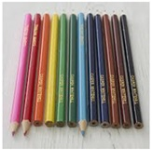
How many is half the set?
Shade one quarter of each shape 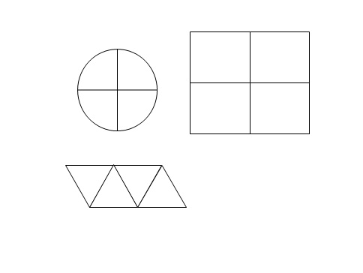

recognise, find and name a quarter as one of four equal parts of an object, shape or quantity
Four Children share 12 strawberries into equal parts.
How many strawberries will each child have?
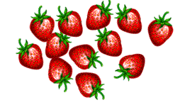

Non-Statutory Guidance
Pupils are taught half and quarter as ‘fractions of’ discrete and continuous quantities by solving problems using shapes, objects and quantities. For example, they could recognise and find half a length, quantity, set of objects or shape. Pupils connect halves and quarters to the equal sharing and grouping of sets of objects and to measures, as well as recognising and combining halves and quarters as parts of a whole.

