Examples of what children should be able to do, in relation to each (boxed) Programme of Study statement
multiply multi-digit numbers up to 4 digits by a two-digit whole number using the formal written method of long multiplication

divide numbers up to 4 digits by a two-digit whole number using the formal written method of long division, and interpret remainders as whole number remainders, fractions, or by rounding, as appropriate for the context

divide numbers up to 4 digits by a two-digit number using the formal written method of short division where appropriate, interpreting remainders according to the context

perform mental calculations, including with mixed operations and large numbers

identify common factors, common multiples and prime numbers

use their knowledge of the order of operations to carry out calculations involving the four operations

solve addition and subtraction multi-step problems in contexts, deciding which operations and methods to use and why
Two numbers have a difference of 1.583. One of the numbers is 4.728. What is the other? Is this the only answer?

solve problems involving addition, subtraction, multiplication and division

use estimation to check answers to calculations and determine, in the context of a problem, levels of accuracy
- Identify subtractions they can do without writing anything down
- Identify why it is possible to solve a calculation mentally, explain the clues they looked for and then solve it
- Peter has £10. He buys 3 kg of potatoes at 87p per kg and 750 g of tomatoes at £1.32 per kg. How much money does he have left?
- Each tile is 4 centimetres by 9 centimetres.
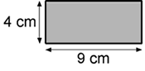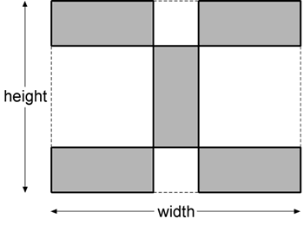
Calculate the width and height of the design.
Write down the calculations that you did

Non-Statutory Guidance
Pupils practise addition, subtraction, multiplication and division for larger numbers, using the formal written methods of columnar addition and subtraction, short and long multiplication, and short and long division
They undertake mental calculations with increasingly large numbers and more complex calculations.
Pupils continue to use all the multiplication tables to calculate mathematical statements in order to maintain their fluency.
Pupils round answers to a specified degree of accuracy, for example, to the nearest 10, 20, 50 etc., but not to a specified number of significant figures.
Pupils explore the order of operations using brackets; for example, 2 + 1 x 3 = 5 and (2 + 1) x 3 = 9.
Common factors can be related to finding equivalent fractions.

