AET Mathematics Written Calculations Policy
Adapted by Plymouth CAST - May 2018

Summary
This calculation policy has been devised to support academies in understanding both the expectations for fluency of the 2014 curriculum and the progression of calculation concepts through a child’s mathematical development.
Principles
- This calculation policy is focused on developing proficiency with the expected formal written methods by the end of Year 6 and hence the progression guidance provided for each operation is designed to flow into the expected method as exemplified on the National Curriculum Appendix document (see page 6 for a summary of these).
- Specific practical equipment and approaches have been suggested for each age group to support children in developing the conceptual understanding that will enable them to move more rapidly and efficiently towards the formal written methods expected.
- It is recommended that teachers encourage children to simultaneously carry out the calculation practically using the equipment/representation suggested and to record this calculation step by step using the parallel formal written method.
- It is expected that academies will work towards the fluency goals for each age group but that, where necessary, teachers will use approaches and materials from earlier year groups to bridge any gaps in a child’s understanding.
- Teachers should have an understanding of the expectations and progression for all year groups, regardless of which year group they teach.
- The ‘Written Methods’, ‘With jottings ...or in your head’ and ‘Just know it’ sections list the national curriculum expectations of the year group for calculation.
- The ‘Developing Conceptual Understanding’ section illustrates how to build children’s understanding of the formal methods using a range of specific practical equipment and representations. The expected language for the formal methods is modelled in this section in the older year groups – this language should be used throughout whenever the formal method is used.
- The ‘Foundations’ section for each year group highlights the skills and knowledge that should be addressed on a regular basis within this year group to ensure that children have the requisite fluency to address the new approaches required.

This policy uses the AET calculation policy as its base and has then been adapted to suit the specific needs of Plymouth CAST.
Reviewed: May 2018
Addition

Written Methods |  | Read, write and interpret mathematical statements involving addition (+), subtraction (–) and equals (=) signs | Add and subtract two two-digit numbers using concrete objects, pictorial representations progressing to formal written methods  4 6  + 2 7  7 3  ¹ | Add and subtract numbers with up to three digits, using formal written methods of columnar addition and subtraction  4 2 3  + 8 8  5 1 1  ¹ ¹ | Add and subtract numbers with up to 4 digits using the formal written methods of columnar addition where appropriate  2 4 5 8  + 5 9 6  3 0 5 4  ¹ ¹ ¹ | Add and subtract whole numbers with more than 4 digits, including using formal written methods (columnar addition and subtraction) | Solve addition and subtraction multi-step problems in contexts, deciding which operations and methods to use and why
Developing conceptual understanding | Children will engage in a wide variety of songs and rhymes, games and activities. They will begin to relate addition to combining two groups of objects, first by counting all and then by counting on from the largest number. They will find one more than a given number. | Number bonds  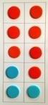  (Ten frame) Numicon  Use bonds of 10 to calculate bonds of 20  Count all  Count on  8  Count on, on number track, in 1s  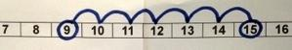  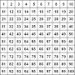  Use a hundred square to count on | Number track / Number line – jumps of 1 then efficient jumps using number bonds  18 + 5 = 23  46 + 27 = 73 Count in tens then bridge.  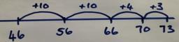  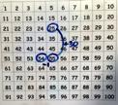  25 + 29 by + 30 then -1  (Round and adjust)  Partition and recombine  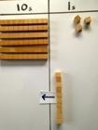  46 + 27 = 60 + 13 = 73  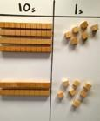  Partitioned column method 2 digit  34 + 41 =  30 + 4  40 + 1  70 + 5 = 75 | Number line: 264 + 158 efficient jumps  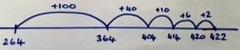  40 + 80 = 120 using 4 + 8 = 12  So 400 + 800 = 1200  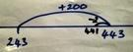  243 + 198  by +200 then -2  (Round and adjust)  Pairs that make 100  23 + 77  Place value counters, 100s, 10s, 1s  264 + 158  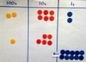  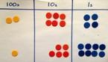  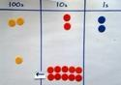  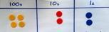  = 422  (Also with £, 10p and 1p)  Partitioned column method  246 + 132 = 378  200 + 40 + 6  100 + 30 + 2  300 + 70 + 8 = 378 | Expanded column addition  3 4 5  + 4 6 2  7  1 0 0  7 0 0  8 0 7  Place Value Counters 2458 + 596  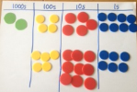  Show 2458 and 596  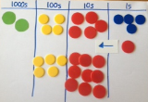  Combine the 1s.  Exchange ten 1s  for a 10 counter.  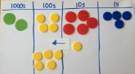  Combine the 10s.  Exchange ten 10s  for a 100 counter.  Combine the 100s.  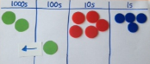  Exchange ten 100s  for a 1000 counter  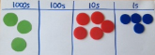  Read final answer  Three thousand and  fifty-four. | 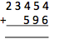  Set out the calculation  In columns.  Find the sum of the ones.  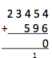  4 ones + 6 ones = 10 ones  (or 1 ten and 0 ones)  so record 0 in the ones and  1 below the line in the tens.  Find the sum of the tens.  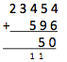  5 tens + 9 tens + 1 ten  = 15 tens (or 1 hundred  and 5 tens) so record a  5 in the tens and 1 below  the line in the hundreds.  Find the sum of the hundreds.  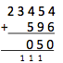  4 hundreds + 5 hundreds  + 1 hundred = 10 hundreds  (or 1 thousand and  0 hundreds) so record a  0 in the hundreds and a  1 in the thousands.  Find the sum of the thousands.  3 thousands + 1 thousand  = 4 thousands so record a  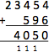  4 in the thousands column.  Find the sum of the ten thousands.  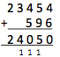  There are only 2 ten thousands  so record a 2 in the final column
With jottings  … or in your head |  | Solve one-step problems that involve addition and subtraction, using concrete objects and pictorial representations, and missing number problems such as 7 = ☐ – 9 | Add and subtract numbers using concrete objects, pictorial representations, and mentally, including:  - a two-digit number and ones  - a two-digit number and tens  - two two-digit numbers  - adding three one-digit numbers | Add and subtract numbers mentally, including:  - a three-digit number and ones  - a three-digit number and tens  - a three-digit number and hundreds | Solve addition and subtraction two-step problems in contexts, deciding which operations and methods to use and why | Add and subtract numbers mentally with increasingly large numbers | Perform mental calculations, including with mixed operations and large numbers
Just know it! | 1 more of numbers up to 10  Doubles of numbers up to 10 | Represent & use number bonds and related subtraction facts within 20  Add and subtract one-digit and two-digit numbers to 20, including zero | Recall and use addition and subtraction facts to 20 fluently, and derive and use related facts up to 100
Year | F | 1 | 2 | 3 | 4 | 5 | 6
Foundations  - addition | 1 more | 1 more | 10 more  Number bonds: 20, 12, 13 | Add multiples of 10, 100 | Add multiples of 10s , 100s, 1000s | Add multiples of 10s , 100s, 1000s, tenths, | Add multiples of 10s , 100s, 1000s, tenths, hundredths
 | Doubles up to 5 | Number bonds: 5, 6 | Number bonds: 14,15  Add 1 digit to 2 digit by bridging. | Add single digit bridging through boundaries | Fluency of 2 digit + 2 digit | Fluency of 2 digit + 2 digit including with decimals | Fluency of 2 digit + 2 digit including with decimals
 |  | Largest number first.  Number bonds: 7, 8 | Partition second number, add tens then ones | Partition second number to add  Pairs of 100 | Partition second number to add  Decimal pairs of 10 and 1 | Partition second number to add | Partition second number to add
 |  | Add 10.  Number bonds: 9, 10 | Add 10 and multiples.  Number bonds: 16 and 17 | Use near doubles to add | Use near doubles to add | Use number facts, bridging and place value | Use number facts, bridging and place value
 |  | Ten plus ones.  Doubles up to 10 | Doubles up to 20 and multiples of 5  Add near multiples of 10. | Add near multiples of 10 and 100 by rounding and adjusting | Adjust both numbers before adding  Add near multiples | Adjust numbers to add | Adjust numbers to add
 |  | Use number bonds of 10 to derive bonds of 11 | Number bonds: 18, 19  Partition and recombine | Partition and recombine | Partition and recombine | Partition and recombine | Partition and recombine

Subtraction

Written Methods |  | Read, write and interpret mathematical statements involving addition (+), subtraction (–) and equals (=) signs | Add and subtract two two-digit numbers using concrete objects, pictorial representations progressing to formal written methods ₆ ₁  7 3  - 4 6  2 7 | Add and subtract numbers with up to three digits, using formal written methods of columnar addition and subtraction ₂ ₃ ₁  3 4 4  - 1 8 7  1 5 7 | Add and subtract numbers with up to 4 digits using the formal written methods of columnar addition where appropriate  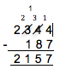 | Add and subtract whole numbers with more than 4 digits, including using formal written methods (columnar addition and subtraction) | Solve addition and subtraction multi-step problems in contexts, deciding which operations and methods to use and why
Developing conceptual understanding | Children will engage in a wide variety of songs and rhymes and practical activities. During these activities and through discussion they will begin to use the vocabulary of subtraction. They will find one less than a given number. They will begin to relate subtraction to ‘taking away’ using objects to count ‘how many are left’ after some have been taken away. | Number bonds  (Ten frame) Difference between 7 and 10  6 less than 10 is 4  Count out, then count how many are left.  7 – 4 = 3  Count back on a number track, then number line.  15 – 6 = 9  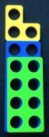  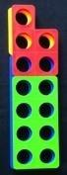  Difference between  13 and 8  13 – 8 = _  8 + _ = 13  Using a hundred square,  counting in 1s | Number track / Number line – jumps of 1 then efficient jumps using number bonds  23 – 5 = 18  Using a number line, 73 – 46 = 26  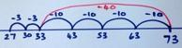  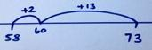  Difference between 73 – 58 by counting up, 58 + _ = 73  Taking away and exchanging, 73 – 46  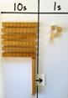  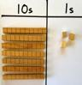  ‘Where’s the Exchange to  ‘forty and six?’ create ‘sixty thirteen’  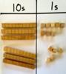  ‘Twenty seven’  ‘Now take away  the forty and six’  Using a hundred square  Partition subtract tens  then ones. | Taking away and exchanging, 344 – 187  Place value counters  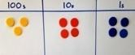  ‘Where’s the one  hundred and  eighty and  seven?  Exchange to create  three hundred and  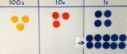  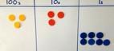  thirty and fourteen.  Now take away the  ‘seven’  Exchange to create two hundred, thirteen tens and seven  Now take away  the ‘eighty’  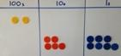  Now take away  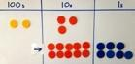  the ‘one hundred’  Partitioning column method  89 – 35 =  80 + 9  - 30 + 5  50 + 4 | 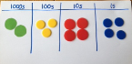  Taking away and exchanging, 2344 – 187  Place value counters  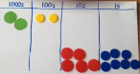  Where’s the one hundred and eighty- seven?  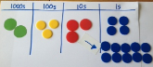  Exchange a 10 for ten 1s to create two thousand, three hundred and thirty and fourteen.  Now take away ‘seven’.  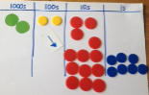  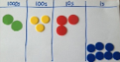  Exchange a 100 for ten 10s to create two thousand, two hundred, thirteen tens and seven.  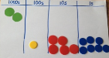  Now take away ‘eighty’  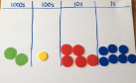  Now take away ‘one hundred’  There are no thousands to take away.  Partitioning column method including exchanging. | 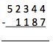  Set out the calculation in columns  The 1s column: four subtract seven  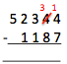  Because seven is greater  than four, exchange a 10 for  ten 1s. So there are now  three 10s and fourteen 1s.  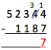  Fourteen 1s subtract seven 1s  makes seven 1s – record this.  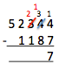  The 10s column: three subtract eight. Because eight is greater  than three, exchange a 100 for  ten 10s. So there are now two  100s and thirteen 10s.  Thirteen 10s subtract eight 10s  makes five 10s – record this.  The 100s column: two subtract one. Two 100s subtract one 100  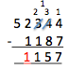  makes one 100 – record this.  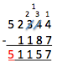  The 1000s column: two subtract one. Two 1000s subtract one 1000 makes one 1000 – record this.  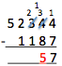  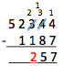  The 10,000s column: there are only five 10000s with nothing to subtract. So record 5.
With jottings  … or in your head |  | Solve one-step problems that involve addition and subtraction, using concrete objects and pictorial representations, and missing number problems such as 7 = ☐ – 9 | Add and subtract numbers using concrete objects, pictorial representations, and mentally, including:  - a two-digit number and ones  - a two-digit number and tens  - two two-digit numbers  - adding three one-digit numbers | Add and subtract numbers mentally, including:  - a three-digit number and ones  - a three-digit number and tens  - a three-digit number and hundreds | Solve addition and subtraction two-step problems in contexts, deciding which operations and methods to use and why | Add and subtract numbers mentally with increasingly large numbers | Perform mental calculations, including with mixed operations and large numbers
Just know it! | I less of numbers up to 10 | Represent and use number bonds and related subtraction facts within 20  Add and subtract one-digit and two-digit numbers to 20, incl zero | Recall and use addition and subtraction facts to 20 fluently, and derive and use related facts up to 100
Year | F | 1 | 2 | 3 | 4 | 5 | 6
Foundations | 1 less | 1 less | 10 less  Number bonds, subtraction: 20, 12, 13 | Subtract multiples of 10 and 100 | Subtract multiples of 10s , 100s, 1000s | Subtract multiples of 10s , 100s, 1000s, tenths, | Subtract multiples of 10s , 100s, 1000s, tenths, hundredths
 |  | Number bonds, subtraction: 5, 6 | Number bonds, subtraction: 14, 15 Subtract 1 digit from 2 digit by bridging | Subtract single digit by bridging through boundaries | Fluency of 2 digit subtract 2 digit | Fluency of 2 digit - 2 digit including with decimals | Fluency of 2 digit - 2 digit including with decimals
 |  | Count back  Number bonds, subtraction: 7, 8 | Partition second number, count back in 10s then 1s | Partition second number to subtract | Partition second number to subtract  Decimal subtraction from 10 or 1 | Partition second number to subtract | Partition second number to subtract
 |  | Subtract 10.  Number bonds, subtraction: 9, 10 | Subtract 10 and multiples of 10  Number bonds, subtraction: 16, 17 | Difference between | Difference between | Difference between | Use number facts bridging and place value
 |  | Teens subtract 10. | Subtract near multiples of 10 | Subtract near multiples of 10 and 100 by rounding and adjusting | Subtract near multiples by rounding and adjusting | Adjust numbers to subtract | Adjust numbers to subtract
 |  | Difference between | Difference between  Number bonds, subtraction: 18, 19 | Difference between | Difference between | Difference between | Difference between

Multiplication

Written Methods |  |  | Calculate mathematical statements for multiplication and division within the multiplication tables and write them using the multiplication (×), division (÷) and equals (=) signs | Write and calculate mathematical statements for ÷ using the x tables they know progressing to formal written methods. | Multiply two-digit and three-digit numbers by a one-digit number using formal written layout  243  x 6  2058  1 | Multiply numbers up to 4 digits by a one- or two-digit number using a formal written method, including long multiplication for two-digit numbers  243  x 36  7290  1458  8748  1 | Multiply multi-digit numbers up to 4 digits by a two-digit whole number using the formal written method of long multiplication  5172  x 38  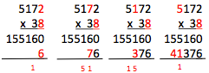 155160  41376  196536  1  To multiply 5172 by 38 find the sum of 5172 x 30 & 5172 x 8.  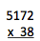  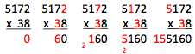  5172 x 30: This is the same as 5172 x 3 x 10. Therefore, record a 0 in the 1s column to take care of the ‘ten times bigger’ and begin to calculate 5182 x 3.  Then calculate 5172 multiplied by 8 and record beneath:  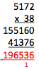  Finally add the  two parts together:
Developing conceptual understanding | Children will engage in a wide variety of songs and rhymes, games and activities. IN practical activities and through discussion they will begin to solve problems involving doubling. | 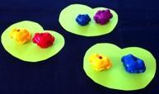  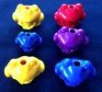  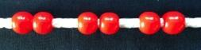  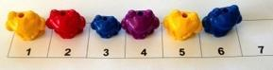  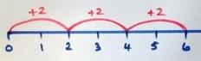  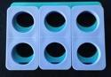  2 frogs on each lily pad. | 5 frogs on each lily pad  5 x 3 = 15  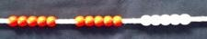  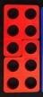  5 x 2 = 2 x 5  Build tables on counting stick  Link to repeated addition  Using arrays | If I know 10 x 8 = 80 then …  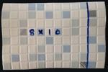  So 13 x 4 = 10 x 4 + 3 x 4  12  40  Build tables on counting stick  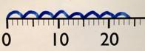  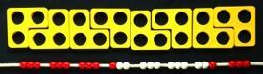  Grid method as an array | 43 x 6 by partitioning  18  240  6  3  40  X  If I know 4 x 6 = 24 the 40 x 60 is ten times bigger.  40 x 6 = 240  3 x 6 = 18  43 x 6 = 258  13 x 16 by partitioning  10 3  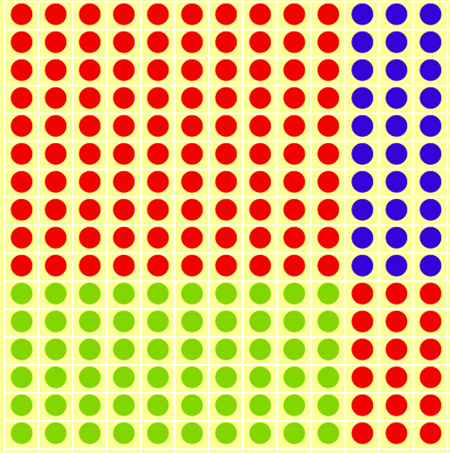  10  6  100 + 30 + 60 + 18 = 208  Build tables on counting stick  Expanded column method  23  X 8  24  160  184 | Grid method linked to formal written method  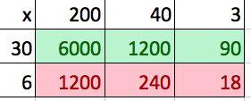  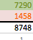  If I know 4 x 6 then 0.4 x 6 is ten times smaller  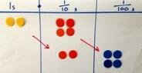  0.4 x 0.6 is ten times smaller again.
With jottings  … or in your head |  | Solve one-step problems involving multiplication and division, by calculating the answer using concrete objects, pictorial representations and arrays with the support of the teacher | Show that multiplication of two numbers can be done in any order (commutative) and division of one number by another cannot  Solve problems involving multiplication and division, using materials, arrays, repeated addition, mental methods, and multiplication and division facts, including problems in contexts | Write and calculate mathematical statements for multiplication and division using the multiplication tables that they know, including for two-digit numbers times one-digit numbers, using mental methods | Use place value, known and derived facts to multiply and divide mentally, including: multiplying by 0 and 1; dividing by 1; multiplying together three numbers  Recognise and use factor pairs and commutativity in mental calculations | Multiply and divide numbers mentally drawing upon known facts  Multiply and divide whole numbers and those involving decimals by 10, 100 and 1000  Identify multiples and factors, including finding all factor pairs of a number, and common factors of two numbers  establish whether a number up to 100 is prime | Perform mental calculations, including with mixed operations and large numbers
Just know it! |  | Count in multiples of twos, fives and tens | Recall and use x and ÷ facts for the 2, 5 and 10 x tables, including recognising odd and even numbers. | Recall and use x and ÷ facts for the 3, 4 and 8 times tables. | Recall x and ÷ facts for x tables up to 12 x 12. | Recall prime numbers up to 19  know and use the vocabulary of prime numbers, prime factors and composite (non-prime) numbers  Recognise and use square numbers and cube numbers, and the notation for squared (²) and cubed (³)
Year | F | 1 | 2 | 3 | 4 | 5 | 6
Foundations | Count in 2s to 20 | Count in 2s | 2 x table | Review 2x, 5x and 10x | 4x, 8x tables  10 times bigger | 4x, 8x tables  100, 1000 times bigger | Multiplication facts up to 12 x 12
 |  | Count in 10s | 10 x table | 4x table | 3x, 6x and 12x tables | 3x, 6x and 12x tables  10, 100, 1000 times smaller | Partition to multiply mentally
 |  | Doubles up to 10 | Doubles up to 20 and multiples of 5 | Double two digit numbers | Double larger numbers and decimals | Double larger numbers and decimals | Double larger numbers and decimals
 |  | Count in 5s | 5 x table | 8 x table | 3x, 9x tables | 3x, 9x tables | Multiplication facts up to 12 x 12
 |  | Double multiples of 10 | Count in 3s | 3 x table | 11x, 7 x tables | 11x , 7 x tables  Partition to multiply mentally | Partition to multiply mentally
 |  | Count in 2s, 5s and 10s | 2 x, 5 x and 10 x tables | 6 x table or review others | 6x, 12 x tables | 6x, 12 x tables | Double larger numbers and decimals

Division

Written Methods |  |  | Calculate mathematical statements for multiplication and division within the multiplication tables and write them using the multiplication (×), division (÷) and equals (=) signs | Write and calculate mathematical statements for ÷ using the x tables they know progressing to formal written methods. |  | Divide numbers up to 4 digits by a one-digit number using the formal written method of short division and interpret remainders appropriately for the context 194 ⎟ 6  3 2  6 1 9 ¹2  192 ⎟ 6 = 32 | Divide numbers up to 4-digits by a two-digit whole number using the formal written method of short division where appropriate for the context  Known multiplication facts:  13, 26, 39, 52, 65, …  10 x 13 = 130, 20 x 13 = 260 …  564 ⎟ 13  4 3 r 5  13 5 6 ⁴4  564 ⎟ 13 = 43 r 5 = 43 $\frac{5}{13}$  Divide numbers up to 4 digits by a two-digit whole number using the formal written method of long division, and interpret remainders as whole number remainders, fractions, or by rounding, as appropriate for the context  564 ⎟ 13 4 3 . 3 8 …  13 5 6 4 . 0 0 …  5 2  4 4  - 3 9  5 0  - 3 9  1 1 0  - 1 0 4  6  = 43 r 5 = 43 $\frac{5}{13}$ = 43.4 (to 1dp)
Developing conceptual understanding | Children will engage in a wide variety of songs and rhymes, games and activities. IN practical activities and through discussion they will begin to solve problems involving halving and sharing. | 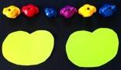  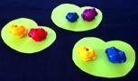  6 ÷2 = 3 by sharing into 2 groups and by grabbing groups of 2  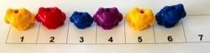  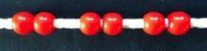  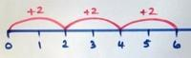  How many 2s?  Fractions of objects ½ ¼ | 15 ÷ 3 = 5 in each group (sharing)  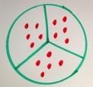  Link to fractions  15 ÷ 3 = 5 groups of 3 (grouping)  10 ÷2 = 5  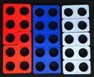  Use language of division linked to tables  How many 2s?  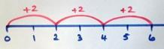  Using arrays | 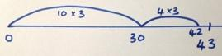  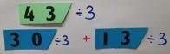  Grouping using partitioning  43 ÷ 3 If I know 10 x 3 …  Use language of division linked to tables  How many 3s? | Grouping using partitioning  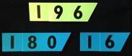  196 ÷ 6 If I know 3 x 6 … then 30 x 6…  ‘Chunking up’ on a number line  196 ÷ 6 = 32 r 4  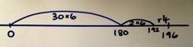  Use language of division linked to tables.  Using place value counters  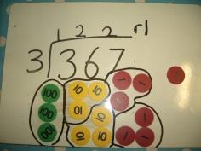 | 192 ÷ 6 using place value counters to support written method  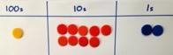  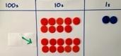  Exchange one  100 for ten 10s  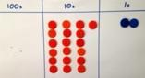  19 tens into  groups of 6  3 groups so that is 30 x 6,  exchange remaining 10 for ten 1s  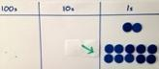  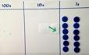  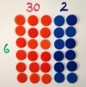  So 192 ÷ 6 = 32
With jottings  … or in your head |  | Solve one-step problems involving multiplication and division, by calculating the answer using concrete objects, pictorial representations and arrays with the support of the teacher | Show that multiplication of two numbers can be done in any order (commutative) and division of one number by another cannot  Solve problems involving multiplication and division, using materials, arrays, repeated addition, mental methods, and multiplication and division facts, including problems in contexts | Write and calculate mathematical statements for multiplication and division using the multiplication tables that they know, including for two-digit numbers times one-digit numbers, using mental methods | Use place value, known and derived facts to multiply and divide mentally, including: multiplying by 0 and 1; dividing by 1; multiplying together three numbers  Recognise and use factor pairs and commutativity in mental calculations | Multiply and divide numbers mentally drawing upon known facts  Multiply and divide whole numbers and those involving decimals by 10, 100 and 1000 | Perform mental calculations, including with mixed operations and large numbers
Just know it! |  | Count in multiples of twos, fives and tens | Recall and use x and ÷ facts for the 2, 5 and 10 x tables, including recognising odd and even numbers. | Recall and use x and ÷ facts for the 3, 4 and 8 times tables | Recall x and ÷ facts for x tables up to 12 x 12. | Recall prime numbers up to 19  know and use the vocabulary of prime numbers, prime factors and composite (non-prime) numbers
Year | F | 1 | 2 | 3 | 4 | 5 | 6
Foundations |  | Count back in 2s | Division facts (2 x table) | Review division facts (2x, 5x, 10x table) | Division facts (4x, 8x tables)  10 times smaller | Division facts (4x, 8x tables)  100, 1000 times smaller | Division facts (up to 12 x 12)
 |  | Count back in 10s | Division facts (10 x table) | Division facts (4 x table) | Division facts (3x, 6 x, 12x tables) | Division facts (3x, 6 x, 12x tables)  Partition to divide mentally | Partition to divide mentally
 |  | Halves up to 10 | Halves up to 20 | Halve two digit numbers | Halve larger numbers and decimals | Halve larger numbers and decimals | Halve larger numbers and decimals
 |  | Count back in 5s | Division facts (5 x table) | Division facts (8 x table) | Division facts (3x, 9x tables) | Division facts (3x, 9x tables)  100, 1000 times smaller | Division facts (up to 12 x 12)
 |  | Halve multiples of 10 | Count back in 3s | Division facts (3 x table) | Division facts (11x, 7x tables) | Review division facts (11x, 7x tables)  Partition decimals to divide mentally | Partition to divide mentally
 |  | How many 2s? 5s? 10s? | Review division facts (2x, 5x, 10x table) | Division facts (6 x table) or review others | Division facts (6x, 12x tables) | Review division facts (6x, 12x tables) Halve larger numbers and decimals | Halve larger numbers and decimals

Expectations of Calculation in Year 6
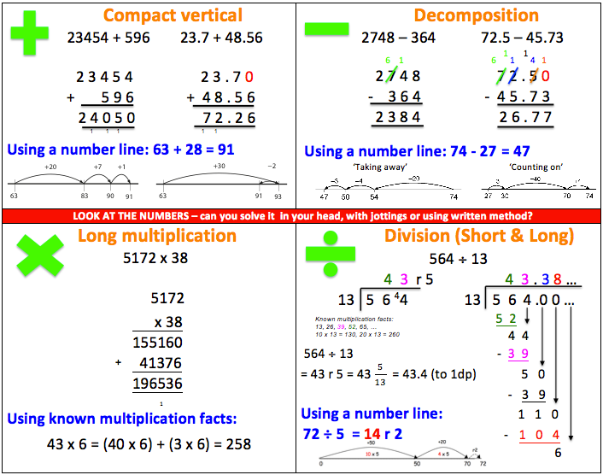
Glossary of Terms

2-digit number– a number with 2 digits like 23, 45, 12 or 60

3-digit number – a number with 3 digits like 123, 542, 903 or 561

Addition facts – knowing that 1+1 = 2 and 1+3 = 4 and 2+5 = 7. Normally we only talk about number facts with totals of 20 and under.

Array - An array is an arrangement of a set of numbers or objects in rows and columns –it is mostly used to show how you can group objects for repeated addition or subtraction.

Bead String/Bar – a string with (usually 100) beads on, grouped by colour in tens. The bead string is a good bridge between a number track and a number line as it maintains the cardinality of the numbers whilst beginning to develop the concepts of counting ‘spaces’ rather than objects.

Bridging – when a calculation causes you to cross a ‘ten boundary’ or a ‘hundred boundary’ e.g. 85 + 18 will bridge 100.

Compact vertical – the name of the recommended written method for addition whereby the numbers are added in columns, 1s first then 10s and so on. Where the total exceeds 10, the ten 1s are exchanged for a 10 and written below the answer line. Sometimes referred to as ‘carrying’.

Concrete apparatus – objects to help children count and calculate– these are most often cubes (multilink) but can be anything they can hold and move including Cuisenaire rods, Dienes rods (hundreds, tens and units blocks), straws, Numicon, Place Value counters and much more.

Count all – when you add by counting all the items/objects e.g. to add 11 and 5 you would count out 11, then count out 5, then put them together and count them all to get 16.

Count on – when you add (or sometimes subtract) by counting onwards from a given number. E.g. to add 11 and 5 you would count on 5 from 11 i.e. 12, 13, 14, 15, 16

Decimal number – a number with a decimal point e.g. 2.34 (said as two point three four)

Decomposition – the name of the recommended written method for subtraction whereby the smaller number is subtracted from the larger, 1s first then 10s and so on. Where the subtraction cannot be completed as the second number is larger than the first, a 10 is exchanged for ten 1s to facilitate this. This is the traditional ‘borrowing’ form of column method, which is different to the ‘payback’ method.

Dienes Rods (or Base 10) – this is a set of practical equipment that represents the numbers to help children with place value and calculation. The Dienes rods show 1s, 10s, 100s and 1000s as blocks of cubes that children can then combine. Dienes rods do not break up so the child has to ‘exchange’ them for smaller or larger blocks where necessary.

Difference – the gap between numbers that is found by subtraction e.g. 7-5 can be read as ‘7 take away 5’ or as the ‘difference between 7 and 5’

Dividend – the number being divided in a calculation

Divisor – the smaller number in a division calculation.

Double – multiply a number by 2

Efficient Methods – the method(s) that will solve the calculation most rapidly and easily

Equals - is worth the same as (be careful not to emphasise the use of = to show the answer)

Exchanging – Swapping a ‘10’ for ten ‘1s’ or a ‘100’ for ten ‘10s’ or vice versa (used in addition and subtraction when ‘moving’ ‘ten’ or a ‘hundred’ from its column into the next column and splitting it up). Heavily relied upon for addition and subtraction of larger numbers. Skills in this can be built up practically with objects, then Dienes rods/base 10, then place value counters before relying on a solely written method.

Expanded Multiplication – a method for multiplication where each stage is written down and then added up at the end in a column

Factor – a number that divides exactly into another number, without remainder

Grid method – a method for multiplying two numbers together involving partitioning and multiplying each piece separately.

Grouping – an approach to division where the dividend is split into groups of the size of the divisor and the number of groups created are then counted.

Half - a number, shape or quantity divided into 2 equal parts

Halve – divide a number by 2

Integer - a whole number (i.e. one with no decimal point)

Inverse – the opposite operation. For example, addition is the inverse of subtraction and multiplication is the inverse of division.

Known Multiplication Facts – times tables and other number facts that can be recalled quickly to support with larger or related calculations e.g. if you know 4x7 then you also know 40 x 70, 4 x 0.7 etc.

Long Division – formal written of division where the remainders are calculated in writing each time (extended version of short division)

Long Multiplication – formal written method of column multiplication

Multiple - a number which is an exact product of another number i.e. a number which is in the times table of another number

Number bonds – 2 numbers that add together to make a given total, e.g. 8 and 2 bond to 10 or 73 and 27 bond to 100

Number line – a line either with numbers or without (a blank numberline).
The number line emphasises the continuous nature of numbers and the existence of ‘in-between’ numbers that are not whole. It is based around the gaps between numbers.
Children use this tool to help them count on or count back for addition of subtraction. As they get older, children will count in ‘jumps’ on a number line e.g. to add 142 to a number they may ‘jump’ 100 and then 40 and then 2. The number line is sometimes used in multiplication and division but can be time consuming.

Number track – a sequence of numbers, each inside its own square. It is a simplified version of the number line that emphasises the whole numbers.

Numicon – practical maths equipment that teaches children the names and values of numbers 1-10 initially but them helps them with early addition, subtraction, multiplication and division. Numicon is useful for showing the real value of a number practically.

One-Step Calculation – a calculation involving only one operation e.g. addition. Usually the child must decide what that operation is.

Partition – split up a larger number into parts, such as the hundreds, tens and units e.g. 342 can be partitioned into 300 and 40 and 2

Place Value – the value of a digit created by its position in a number e.g. 3 represents thirty in 234 but three thousand in 3567

Recombine – for addition, once you have partitioned numbers into hundreds, tens and units then you have to add then hundreds together, then add the tens to that total, then add the units to that total

Remainder – a whole number left over after a division calculation

Repeated addition – repeatedly adding groups of the same size for multiplication

Scaling – an approach to multiplication whereby the number is ‘scaled up’ by a factor of the multiplier e.g. 4 x 3 means 4 scaled up by a factor of 3.

Sharing – an approach to division whereby the dividend is shared out into a given number of groups (like dealing cards)

Short Division - traditional method for division with a single digit divisor (this is a compact version of long division, sometimes called ‘bus stop’)

Significant digit – the digit in a number with the largest value e.g. in 34 the most significant digit is the 3, as it has a value of ‘30’ and the ‘4’ only has a value of ‘4’

Single digit – a number with only one digit. These are always less than 10.

Sum – the total of two or more numbers (it implies addition). Sum should not be used as a synonym for calculation.

Two-step calculation - a calculation where two different operations must be applied e.g. to find change in a shop you will usually have to add the individual prices and then subtract from the total amount. Usually the child has to decide what these two operations are and the order in which they should be applied.

