The Team
Teacher: Mrs Quick Tuesday pm PPA cover: Mrs Walker
Teaching Assistant: Miss Wallis

Our Curriculum
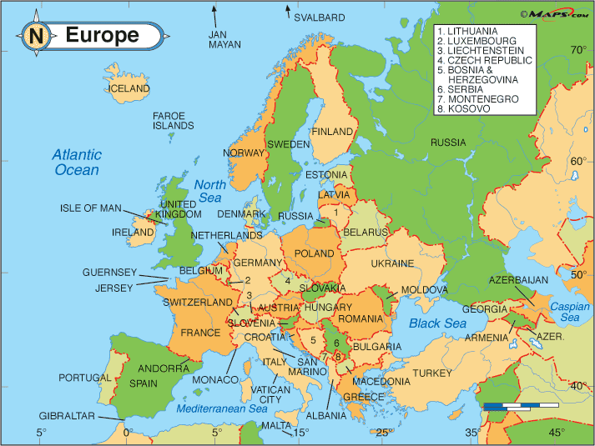
In Year 4 (Peace Class), we will be looking at a fun and exciting range of topics linking across all of our subjects. Our main themes are Mountains and Europe this term. Please see the attached topic map for a more detailed overview of the Year 4 curriculum for the spring term. The summer overview will be sent out at the start of the summer term.

Home Learning
Reading: You will be expected to read daily at home and bring your reading book and Home/School link book to school every day. As this becomes an established part of your daily routine, we will then be able to concentrate more on developing comprehension skills in school.
Spellings: You will continue to practise spellings daily in school and will add keywords to your personal spelling log.
Rapid Recall Challenge & Times Tables Rockstars: Please continue to practise and learn these vital number bonds at home so that they can be applied to our learning in school. We will build regular Times Tables Rockstars sessions into our classroom maths, which you’ll be able to practise at home as well!
Home Learning Grid: The above activities, alongside other more creative projects from across the curriculum are included on the attached home learning grid. Please complete as many of these as you are able to before the end of term.

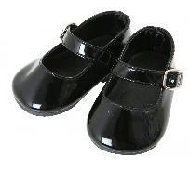
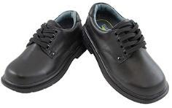
Year 4 Expectations and Reminders
In Key Stage 2, we are role models to the younger children with both our behaviour and our appearance. You need to make sure that you are wearing the correct uniform at all times. This means tucking your shirt in and wearing a school tie (unless you prefer a polo shirt) and wearing black school shoes, not trainers. If you need to check the uniform rules, you can get this information from the office or school website.
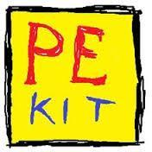
Children are required to wear their PE kits all day on PE days. All Year 4 (Peace Class) children will need to wear PE kit to school on a Monday and Friday. Children can wear black leggings, joggers or shorts with their yellow PE top and school jumper. They will be allowed to wear their coats too if it is particularly cold or wet, so please ensure one is brought into school daily.
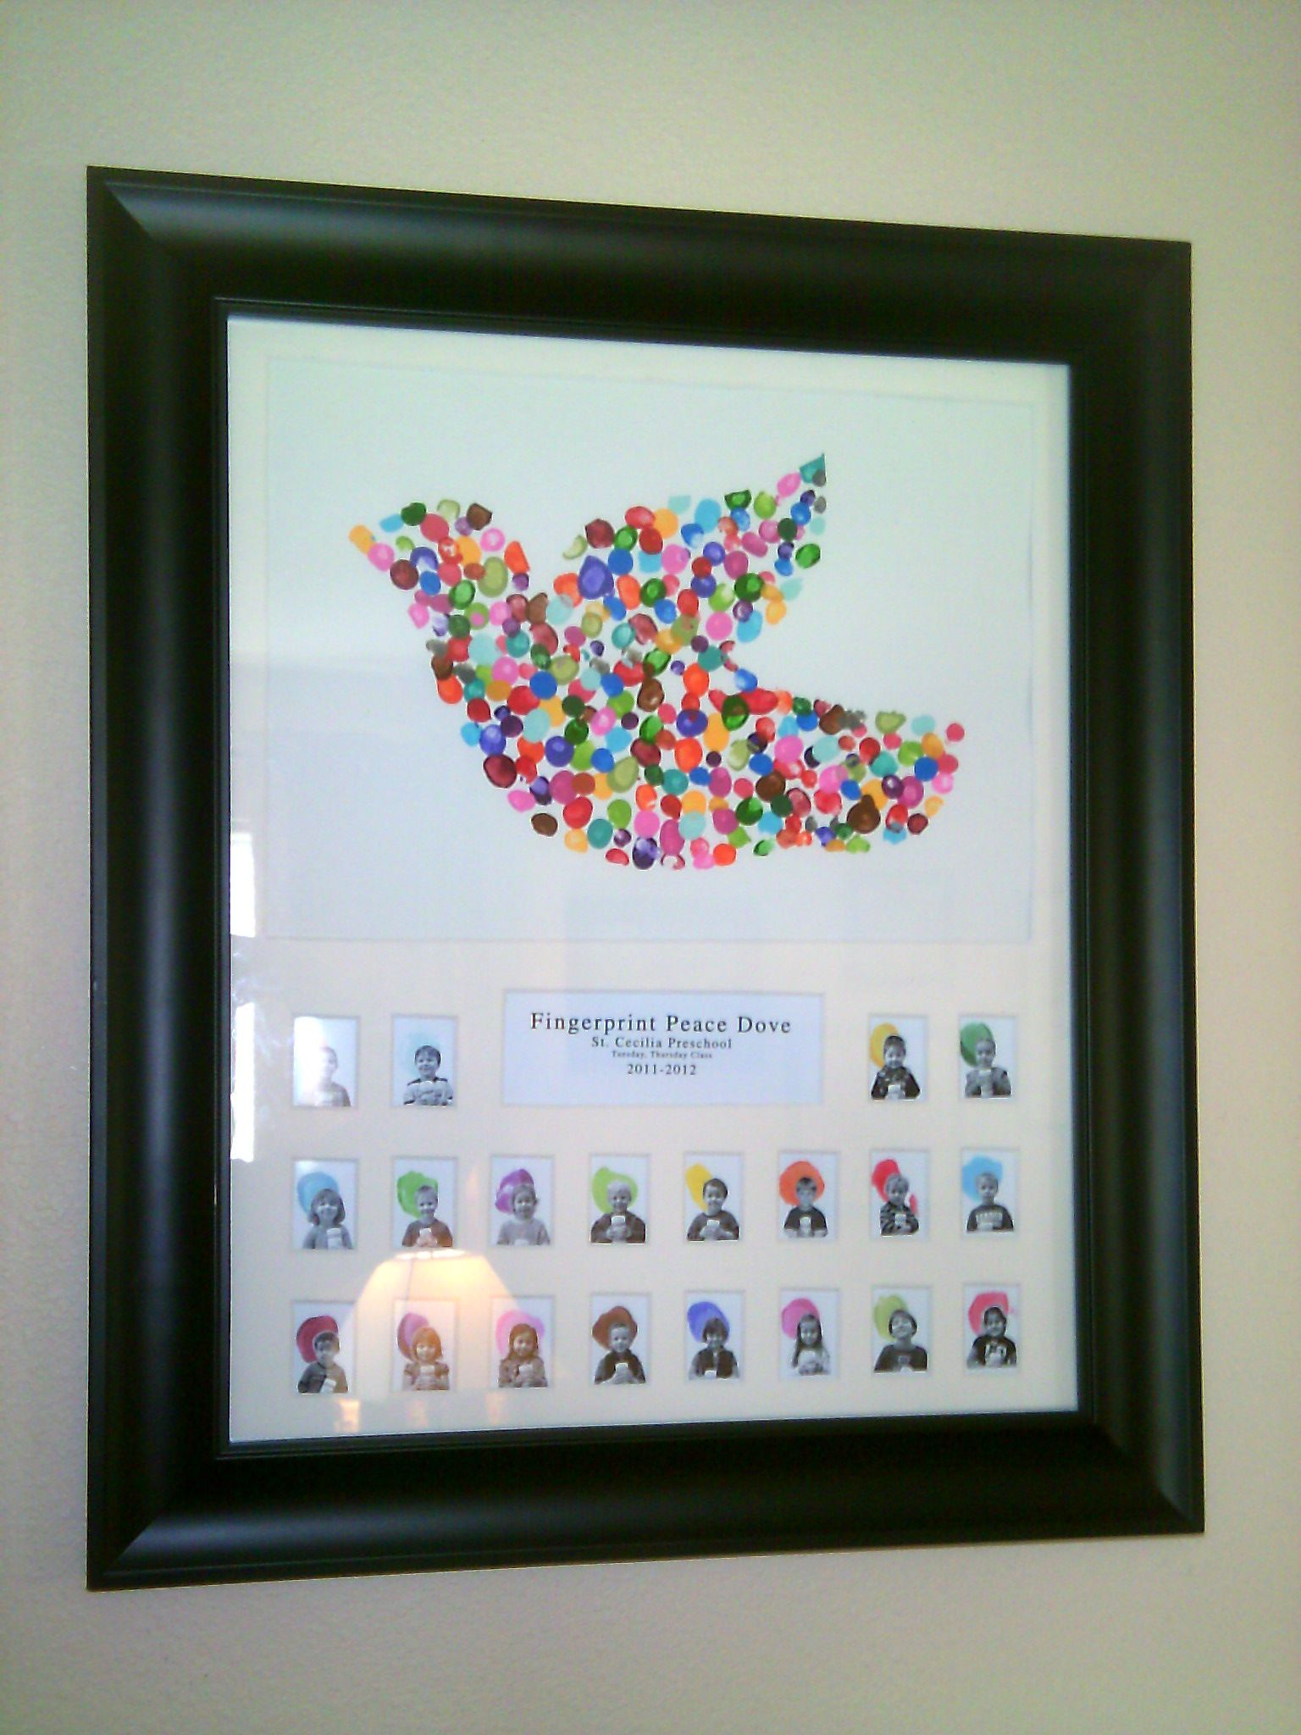
Children must not bring in any stationery from home. All equipment will be provided by the school. Children are now able to bring a bag to school..
If you have any queries or concerns, please contact the school office who will be able to pass on any messages or catch me at the end of the school day.

Yours sincerely,
Mrs Quick

