Learning letter
WB 27.9.20

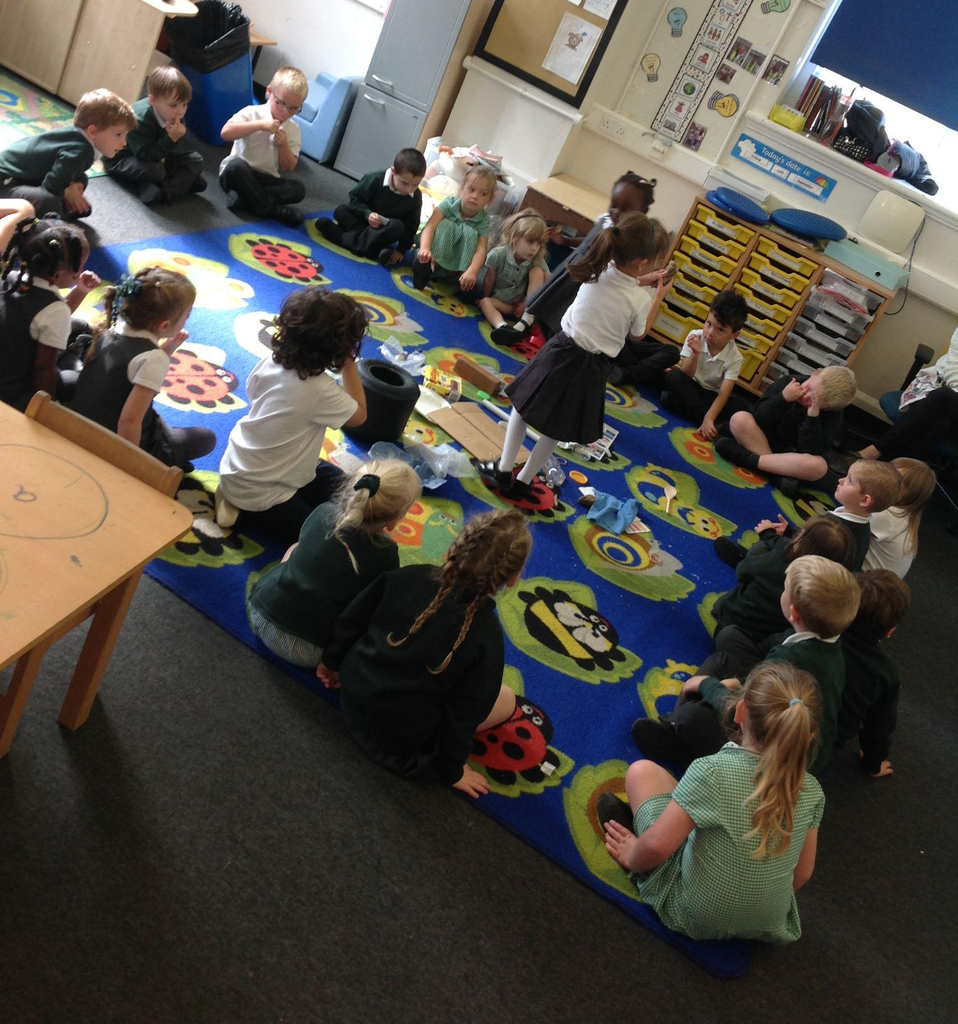
We’ve had a great week, starting our formal Maths lessons and Science. We had really enjoyed finding out about different Materials. Thank you for all the material donations! Please do continue as we will be doing DT soon too! Here is a picture of us playing a game to find the type of material first!

Things we have been learning:
- to keep our classroom super tidy to help our learning
- road safety
- to recognise and write our name
- how to sort objects into different groups
- cutting skills
- what different materials there are and how we can change them
- in RWI we have learnt the sounds i, n, p, g, o

Homelearning
Homelearning is optional but anything you do at home is a great help for your child!
- Please read and enjoy pages 14-16 together. We have on order our new phonics books for reading the sounds we have been learning.
- Sound sheets- these include a sheet for each letter with a ditty. Say this ditty as you form the letter to help the children correctly write their letters. Always create the circular letters anti clockwise!
- Have a look at Tapestry together.

Dojos
We have loved hearing how excited children are about dojos! We use dojo to give out positive praise points which are reset each day and counted up at the end of the week. These are linked to our keyham keys! We have been focusing on listening lion and choosing chimp.

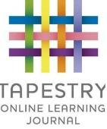
Tapestry
Please enjoy having a look together at Tapestry. It is a lovely relationship building opportunity and helps to develop your child’s oracy (talking) skills as they share what they have done.

Have a lovely weekend!

