Examples of what children should be able to do, in relation to each (boxed) Programme of Study statement
convert between different units of metric measure (for example, kilometre and metre; centimetre and metre; centimetre and millimetre; gram and kilogram; litre and millilitre
What is two hundred and seventy six centimetres to the nearest metre?
How many millimetres are in 3 centimetres?
understand and use approximate equivalences between metric units and common imperial units such as inches, pounds and pints
This bag of sugar weighs 1kg. Approximately how many pounds (lb) of sugar would fit into another empty bag of the same size as this one? Tick the correct answer.
20lb
14lb
2lb
4lb
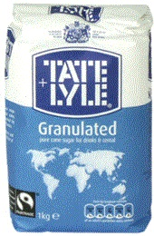

measure and calculate the perimeter of composite rectilinear shapes in centimetres and metres
This shape is made from 4 shaded squares
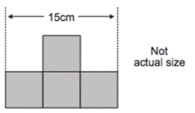
Calculate the perimeter of the shape
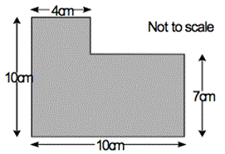
calculate and compare the area of rectangles (including squares), and including using standard units, square centimetres (cm2) and square metres (m2) and estimate the area of irregular shapes
Calculate the area of a rectangle which is eleven metres long by 5 metres wide.
Which has the greatest area – a square with sides 6 cm long or a rectangle which is 7 cm long by 5 cm? How much greater is the area?

estimate volume [for example, using 1 cm3 blocks to build cuboids (including cubes)] and capacity [for example, using water]
Fitting it in is an activity to fill cuboid shapes with multilink cubes. It ends with a ‘create’ challenge that will test children’s knowledge in this area
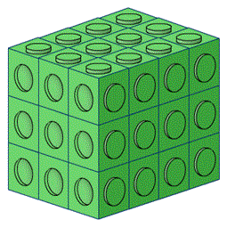
solve problems involving converting between units of time
5 on the clock is a problem that requires children to be able to convert between 12 and 24 hour clocks confidently.
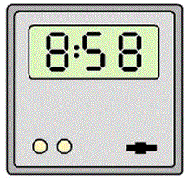
use all four operations to solve problems involving measure [for example, length, mass, volume, money] using decimal notation,
A day with Grandpa. Is an engaging problem using imperial units that challenges children's understanding of the concept of area rather than simply requiring them to follow a rule for finding areas of rectangles. These calculations should also help learners to see the advantages of the metric system as well as understand it more fully!

Non-Statutory Guidance
Pupils use their knowledge of place value and multiplication and division to convert between standard units.
Pupils calculate the perimeter of rectangles and related composite shapes, including using the relations of perimeter or area to find unknown lengths. Missing measures questions such as these can be expressed algebraically, for example 4 + 2b = 20 for a rectangle of sides 2 cm and b cm and perimeter of 20 cm.
Pupils calculate the area from scale drawings using given measurements.
Pupils use all four operations in problems involving time and money, including conversions (for example, days to weeks, expressing the answer as weeks and days).

