Learning letter
WB 13.9.20

Well, we’ve done it! We have completed our first full week of big school at Keyham Barton!

Please send in a photograph (a print to go on the wall or email to hphillips@keyhambarton.plymouth.sch.uk) of you and your family to add to our family tree AND a baby photo please.

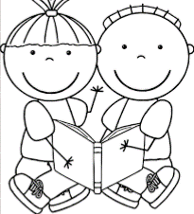
Every Friday we will send a book home, please return on Wednesday. These books have lots of activities to help you share the love of reading with your children before we start thinking about our phonics and our letters. At Keyham Barton, we really want to encourage a love of learning from the beginning. If you need any help with this, please get in touch.

Things we have been learning:
- to keep our classroom super tidy to help our learning
- to put our belongings in the right place
- to say our daily prayers
- to recognise our name and picture
- to learn about why our names are special
- to play together and share our ideas

Homelearning
Homelearning is optional but anything you do at home is a great help for your child!
- Please read and enjoy pages 2-5 together.
- Practise writing your name using the card from your home visit.
- Practice putting on and off jumpers, cardigan buttons and trousers clasps.

Reminders
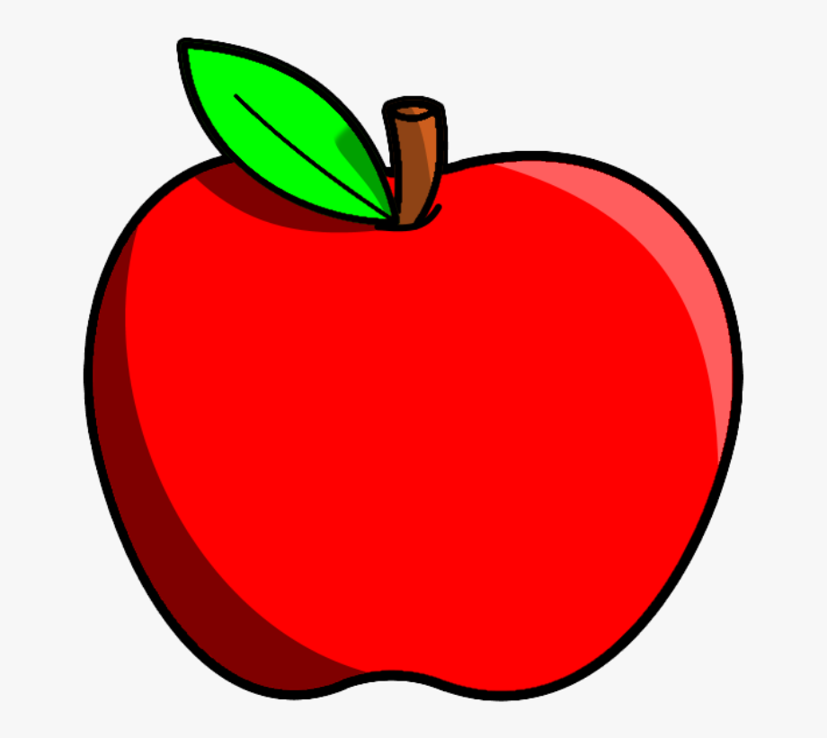
- Water! Nothing else please.
- We provide a fruit snack and milk. If you want your child to have a different snack, please can this be a healthy choice.
- Jumpers- I have lots of jumpers with no names- let me know if you are missing one!

You could be famous!
Jemima Lang (councillor) is writing an article about starting school at Keyham Barton. She has asked if any parents would be happy to be contacted for quotes from children and parents. Please shout if you would like to be!

Have a lovely weekend!

