Examples of what children should be able to do, in relation to each (boxed) Programme of Study statement
complete, read and interpret information in tables, including timetables
I can find the information in a table or graph to answer a question
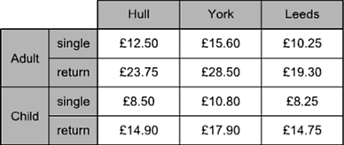
The table shows the cost of coach tickets to different cities.
What is the total cost for a return journey to York for one adult and two children?
Solve comparison, sum and difference problems using information presented in a line graph.
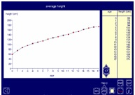
What is the average height of children of different ages?
Are there differences for boys and girls?
This screen shot is from the Interactive Teaching Programme ‘Data Handling’, using the ‘Average Height’ data set.

Non-Statutory Guidance
Pupils connect their work on coordinates and scales to their interpretation of time graphs. They begin to decide which representations of data are most appropriate and why.

