Examples of what children should be able to do, in relation to each (boxed) Programme of Study statement
identify and describe the properties of 2-D shapes, including the number of sides and symmetry in a vertical line
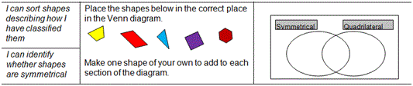
identify and describe the properties of 3-D shapes, including the number of edges, vertices and faces
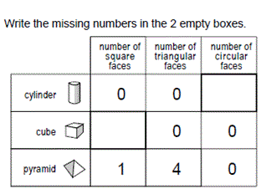
identify 2-D shapes on the surface of 3-D shapes, for example a circle on a cylinder and a triangle on a pyramid
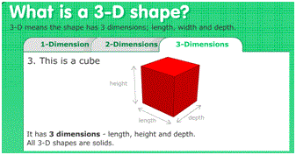
compare and sort common 2-D and 3-D shapes and everyday objects.
Children can sort two sets of 2D and 3D shapes in 2 or more different ways using different criteria each time. For example, they might choose ‘dimensions’ or ‘right angled’

Non-Statutory Guidance
Pupils handle and name a wider variety of common 2-D and 3-D shapes including: quadrilaterals and cuboids, prisms, cones and polygons, and identify the properties of each shape (e.g. number of sides, number of faces). Pupils identify, compare and sort shapes on the basis of their properties and use vocabulary precisely, such as sides, edges, vertices and faces.
Pupils read and write names for shapes that are appropriate for their word reading and spelling.
Pupils draw lines and shapes using a straight edge.

