Examples of what children should be able to do, in relation to each (boxed) Programme of Study statement
Identify 3-D shapes, including cubes and other cuboids, from 2D representations
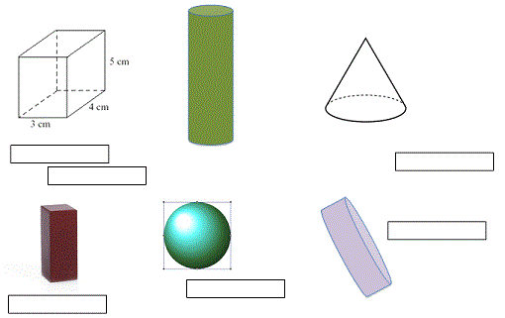
These are pictures of 3D shapes. Which 3D shapes are pictured here? Put the names in the boxes.
Know angles are measured in degrees: estimate and compare acute, obtuse and reflex angles
Look at these angles.
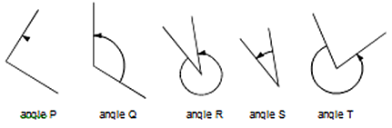
Label each angle acute, obtuse or reflex. List the 5 angles in order from smallest to largest.

Draw given angles, and measure them in degrees (°)
Measure A accurately. Use a protractor (angle measurer).
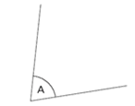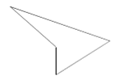
Measure accurately the smallest angle in the above shape. Use a protractor (angle measurer).
This diagram is not drawn accurately. Calculate the size of angle m
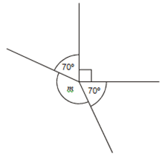

Identify:
- Angles at a point and one whole turn (total 360°)
- Angles at a point on a straight line and ½ a turn (total 180°)
- Other multiples of 90°
PQ is a straight line. Not drawn accurately.
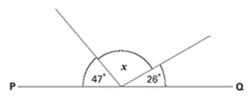
Calculate the size of angle x. Do not use a protractor (angle measurer).
This shape is three-quarters of a circle.
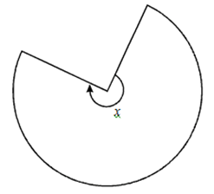
How many degrees is angle x?
In the diagram below, if you were standing at X, facing A, what angle would you turn through if you turn and face C?
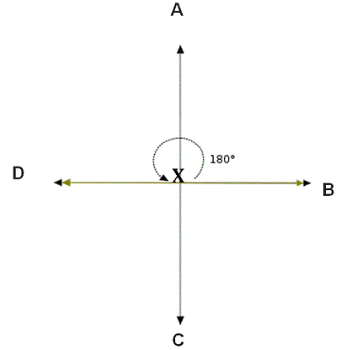
Use the properties of rectangles to deduce related facts and find missing lengths and angles
This online activity
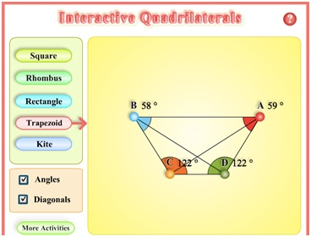
will challenge children’s knowledge about many different kinds of quadrilaterals.
This diagram is not drawn accurately. Calculate the size of angle m

Distinguish between regular and irregular polygons based on reasoning about equal sides and angles
This online activity from softschools.com asks children to classify polygons. They will need to draw on their knowledge of sides and angles.
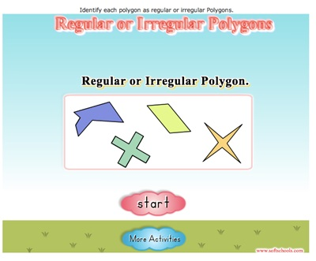

Non-Statutory Guidance
Pupils become accurate in drawing lines with a ruler to the nearest millimetre, and measuring with a protractor. They use conventional markings for parallel lines and right angles.
Pupils use the term diagonal and make conjectures about the angles formed between sides, and between diagonals and parallel sides, and other properties of quadrilaterals, for example using dynamic geometry ICT tools.
Pupils use angle sum facts and other properties to make deductions about missing angles and relate these to missing number problems.

