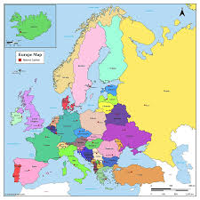
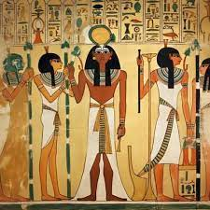

Art/DT

Clay canopic jars

Wraps/
sandwiches

French

Greetings
Numbers
Colours
Classroom instructions
Calendar

Music

Let Your Spirit Fly - sing and play

Glockenspiels unit 1

English
Recapping handwriting
Sentence formation
Conjunctions
Adjectives and adverbs
Portal stories

Maths

Number and place value
Addition and subtraction
Area (Y4 only)
Multiplication and
division

Ancient Egyptians
& Europe

RE

Creation and Covenant

Prophecy and Promise

Science

Animals, including Humans - teeth and digestion

Electricity

History/
Geography

Ancient Egyptians

Europe

Computing

Stop-frame Animation

Audio editing

PE

Football
Dance (meeting and parting)
Netball
Gymnastics (rhythmic)

PSHE

Families and friendships

Safe relationships

