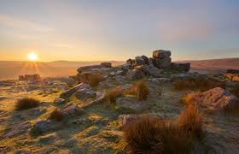
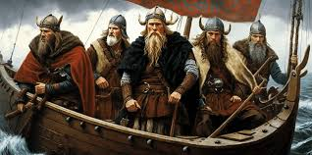

Art/DT

Shadow puppet art

Textiles - soft toys

French

Fruits and vegetables

Going on a picnic

Music

Enjoying improvisation

Opening night (performance skills)

English

Recounts
Dartmoor legends
Poetry
Character flaws
Newspaper writing

Maths

Fractions
Decimals (Y4 only)
Mass and capacity

Dartmoor and Vikings

RE

To the ends of Earth

TBC

Science

Light

Embedding working scientifically skills

History/
Geography

Vikings

Dartmoor

Computing

Desktop publishing

Photo editing

PE

Athletics
Dance
Striking and fielding
Swimming (Y4 only)

PSHE

Physical health

Mental wellbeing

